RCGP Scotland: a brief overview of work carried out by the Primary and Secondary Care Interface Group and its Leads: March 2025

NHS Borders

The NHS Borders Clinical Interface Group (CIG) has been running for a few years now. The group has developed over this time to include operational issues and larger stand-alone projects.

CIG was involved in the development of the GP Role Document, the first local document to detail the GP role in interface issues. The Role Document was initially written by the GP Local Medical Committee. It was then brought to CIG for discussion. This involved review and feedback by senior clinicians from both Primary and Secondary care. CIG agreed and signed off on the document before circulation to other secondary care clinicians. Following CIG agreement, the document was ultimately approved by the Medical Director and circulated to all clinicians. This has helped to clarify the role of GPs within NHS Borders and has led to improvements in the appropriateness of requests being made to GPs. This improves overall efficiency of the whole system and should help to improve the patient journey.

The GP Role Document is comprehensive and is available by request by emailing: scotland.interface@rcgp.org.uk. CIG played a key role in gaining agreement of this. The Document also describes the embedded role of CIG in the Borders. CIG is central to agreeing the terms of interactions such as new referral pathways or accepted ways of working – for example prescribing and result handling at the interface.

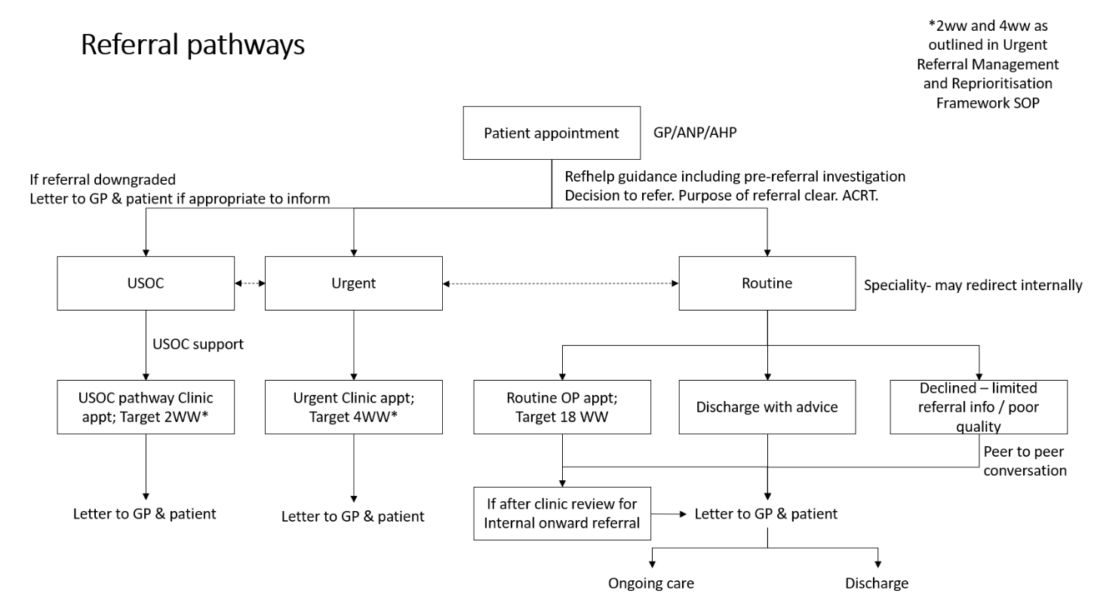

NHS Highlands

There has been significant progress in the group since the RCGP event in September.
The group previously identified several difficulties at the interface relating to communication. They have actively worked to develop good interpersonal relationships at the interface by actively encouraging participation in the group and having a mix of face-to-face and MS Teams meetings. Other outcomes of this work include changes to the Immediate Discharge Letter (IDL) template and agreement that practices will facilitate a direct phone line for secondary care teams to use.

The interface group see their role as being "the group that gets things done". Coaching has helped the group to refine their focus and following this process, the group are testing a simplified SBAR (See template below) approach to interface issues.

Topics being reviewed by SBAR at present include e-communication (FormStream) for medication changes, sepsis management, and qFIT pathways.

Group Format
The learning over the last year has been how to best structure meetings and get the most out of members. They have primary and secondary care leads of the group and 3 interface clinical leads. As a result of the coaching, they’ve decided to have 4 in-person meetings 2 hour long each with a clear theme. They also have 6 online meetings 1 hour long. They have now set up a generic email inbox. It is the responsibility of the co-chairs to come up with the agenda and provide feedback to SBAR contributors. The group has invited operation leads and Head of Service for Primary Care and Acute Services to future meetings. Currently the group have funded admin support. Clinical Director time however taken as a given and is not a part of the job plan. The overall aim of the group is to improve the patient journey and improve working relationship between staff.

What could be improved?
The group are aware of the 'fragility' of the current format. Increased admin support to raise awareness and promote the group has been identified as a requirement. The group needs more funding to ensure ongoing participation of non-clinical staff and of clinicians from primary and secondary care. They need to have valued and meaningful time for people to take part. There could be potential to look more at frailty and hospital at home – which comes down through acute but should be up through Primary Care.

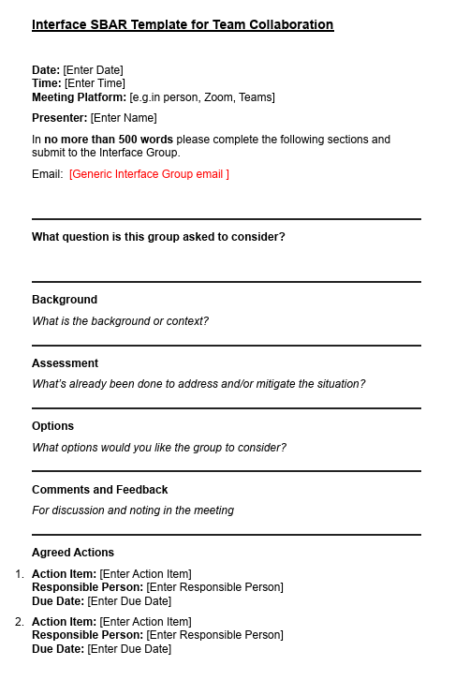
NHS Grampian

Shared Learning Event for Significant Events
The group is hosting shared learning events between Primary and Secondary Care to review Significant Events that have happened at the interface. The first event is due to take place on 16 April. The first seeds of this idea from the Interface Group came from high-risk medication monitoring issues. Significant Events can be siloed in Primary care with not a lot of input from Secondary Care and vice versa. The goal of this shared approach is to encourage system learning with the avoidance of blame.

Challenges
Clinical members do not have the capacity to take on and organise projects. The transformation team has traditionally taken on this role for the group, but this team has now been downsized. Lots of duplication and silos, CTAC Is one example. Funding and operational support would be a big help.

Governance
The group has developed a flow chart of where they sit in the Health Board. They interact with both the Consultant sub-committee and the GP Sub-committee and feed into the Clinical Governance Group. A Terms of Reference document has been produced.

Format of Meetings
The group meets fortnightly for one hour. There is a wide membership, including GPs, clinical leads, cluster lead, chair of consultant subcommittee, psychology consultants, portfolio medical leads, AMDs, anyone who has an interest. On the operational side the planning and innovation team sometimes attend. The group has unofficial admin support. There is no dedicated project manager support. They now have a dedicated email address. No funding from board. Aim of the group is to improve patient pathways. Over the next year the group is planning to look at the following topics:

Creating a teams channel
Requesting pathway QI
Private NHS interface
PSA monitoring
Bariatric surgery
Neurodivergent pathways for adults

