
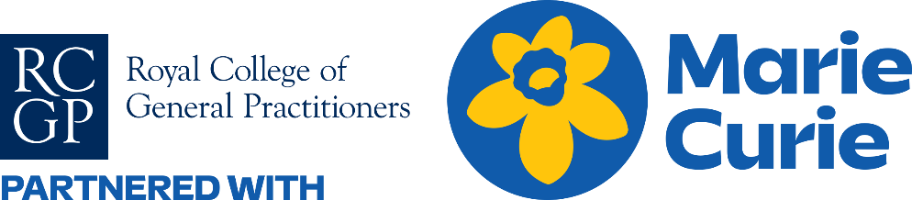

Daffodil Standards Population ​
Improving Health in General Practice: ​
Palliative & End of Life Care & Bereavement Support ​
‘How to Get Started’ Guide - 1 CPD point​

Contents

Page 3 How to get started - Watch the introductory training video
Page 4 How to use this “how to get started” guide
Page 5 Introduction
Page 6 Implementing the Daffodil Standards – a step-by-step guide
Page 7 - 8 Example Six-Month Timeline for Completing the Daffodil Standards
Page 9 Step 1 Sign up, power up your team and brainstorm your ideas
Page 10 Step 2 Familiarise yourself - Daffodil Standards self-assessment breakdown & evidence at a glance
Page 11 - 13 Step 3 Getting Started: Your practice scenario - 3 Common Scenarios
Page 14 Step 4 Which baseline data collection tool?
Page 15 –18 Step 5 Gathering your baseline data Gather: Key considerations
Page 19 - 25 Step 6 Using Audit & Feedback Results to Create SMART GOALS
Page 26 - 27 Step 7 Keep track of progress, celebrate success and plan your next steps
Page 28 Step 8 Quality improvement tools to use for each Standard
Page 29 Population Health & Health Inequalities
Page 30 Using the Daffodil Standards to focus on: Supporting people with learning disabilities and their carers
Page 31 - 32 Using the Daffodil Standards to focus on: Supporting older people in care homes
Page 33 Example Case Studies
Page 34 Acknowledgements
Page 35 Acronyms used in this “how to get started” guide

How to get started

1. Watch introductory video
Please watch this introductory video which will set out how to get started easily



How to use this “how to get started” guide

- Check you are using the latest version by visiting the resources page
- Follow this document page by page – it's designed to guide you step by step.
- Download Daffodil Standards website badge from the resources page
- Watch the introductory training video on page 3 to get started.
- At first glance, the Standards may seem detailed but don’t worry – by following the eight simple steps on page 6,
you will be well on your way through the Daffodil Standards journey!
- Look out for the logo at the top right hand of the page. It will tell you which Standards you will be working
towards completing. By following these eight steps you will be able to begin working towards all eight of the
Daffodil Standards.
- Check off your activity using the checklist to make sure everything is complete.

Additional information can be found on the RCGP Daffodil Standards webpage
If you would like a Marie Curie Daffodil Standards welcome pack posted to your practice, please complete this form.
The welcome pack includes a range of useful patient-facing materials such as posters and leaflets, as well as pens, notebooks
and other resources to support and inspire your team as you embed the Daffodil Standards. There is also the Daffodil Mark,
which can be displayed to highlight the practice's commitment to excellent end of life and bereavement care.
These materials are designed to help facilitate conversations and raise awareness within your practice.

Please note everything you need to get started is included in this document and available on the website.
– the physical pack is a helpful addition.
Daffodil Standards welcome pack

Keep in mind
Introduction

Thank you for signing up to the Daffodil Standards!
The Daffodil Standards, also known as the RCGP and Marie Curie UK General Practice Core Standards for
Advanced Serious Illness and End of Life Care, provide a framework for excellence in end of life care.

The Standards cover eight core areas below.
- Professional and competent staff
- Early identification
- Carer support
- Seamless, planned, coordinated care
- Assessment of unique needs of the patient
- Quality care during the last days of life
- Care after death
- General practices as hubs within compassionate communities
Whatever your starting level, keep it relevant to your practice, your staff and your patients – every improvement counts.
Small steps and changes can result in significant improvements. Based on insights from GP teams, this guide presents
clear, adaptable steps you can work through, at your own pace. By making small, practice-specific improvements you’ll
keep momentum, support your staff and patients, and steadily grow consistently high-quality care.

We encourage you to 'tailor' the implementation of the Standards to your practice and your population.
For example, your practice team should continue to use any locally developed PEOLC tools that complement
the Standards. Each practice team should use the Standards flexibly to suit the needs of your patients.


Implementing the Daffodil Standards – a step-by-step guide
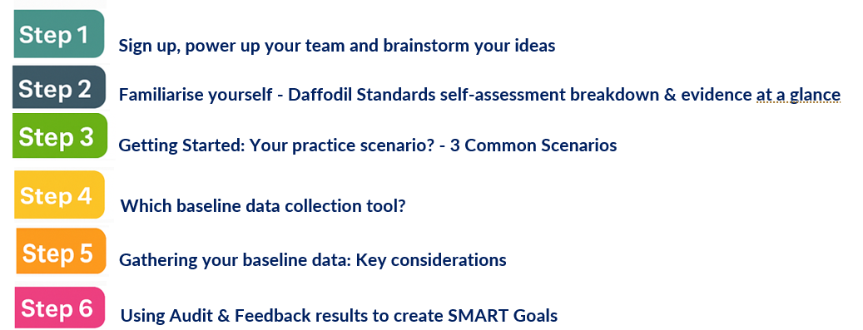
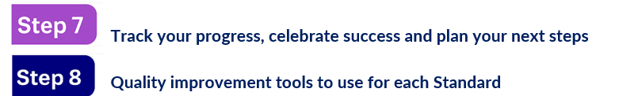

Example Six-Month Timeline for Completing the Daffodil Standards
Below is an example flexible six-month, suggested timeline for completing and embedding the Daffodil Standards
into practice. Timings can be adapted based on your team’s capacity and starting point.
Month 1 – Sign Up & Power Up Your Team
Confirm clinical and non-clinical leads.
Watch the introductory video (page 3) as a team.
Share purpose /benefits of Daffodil Standards with all staff and MDT.
Hold kick-off meeting to introduce Standards and agree your practice scenario (page 11-12). Start the Self-Assessment (page 9) to get an overview of current strengths and gaps.

Month 2 – Select Focus & Prepare
Complete the Self-Assessment.
Choose practice scenario and priority Standards to start with (page 11-12).
Draft initial SMART goals (Step 6) for improvement.
Identify baseline data collection tools & how to gather them.
Agree on equity checks and how you’ll include patient/carer voices.

Month 3 – Gather Baseline Data
Collect audit data (e.g. Population Summary Audit, Death Audit, MDT Audit).
Gather staff, MDT, and patient/carer feedback
Engage your Patient Participation Group to discuss priorities.
Identify training needs using the Staff Training Needs Analysis
(Standard 1).
Keep all evidence in a shared, version-controlled folder.

Example Six-Month Timeline for Completing the Daffodil Standards
Month 4 – Analyse & Pilot Improvements
Review your audit and feedback findings as a team.
Finalise SMART goals and decide small-scale PDSA cycles
Pilot targeted changes (e.g. new MDT template, bereavement process, carer identification process).
Capture early wins and share at team or PCN meetings.

Month 5 – Refine & Embed
Understand your pilot results – what’s working, what’s not?
Adjust processes and roll out successful changes more widely.
Repeat selected audits or feedback collection to measure impact.
Begin integrating changes into standard operating procedures and training.

Month 6 – Sustain & Share
Finalise and standardise successful procedures.
Document processes, templates, and case examples for future use.
Create a final improvement summary for your PCN, PPG, and wider network.
Plan your next cycle of improvement – either moving to other Standards or deepening existing work.
Celebrate your achievements and keep the improvement culture alive.



- Confirm practice clinical lead (this does not need to be a GP) and non-clinical lead
    - Who is best placed (for example, skills, time, desire)?
    - Do they want to brush up on their quality improvement learning?
Examples of modular learning: West of England Academic Health Science Network Education Pathway
or NHS Scotland. The Quality improvement hub provided by Improvement Cymru.

- Involve the practice team
    - Share aim to improve EOLC/ bereavement e.g. practice meeting - communicate and engage all
practice staff to understand goals and can be involved, at an appropriate level
    - Invite staff ideas – for EOLC/ bereavement areas to improve.
    - Consider any SEAs, feedback (positive / negative), complaints – which can support which
Daffodil Standard(s) you choose to start.
    - Reinforce a culture of continuous learning and improvement in the practice.

- Share your aim to improve EOLC/ bereavement with wider members
    - e.g. MDT members, Practice Participation Groups (see PPG pack to support), GP neighbourhood
teams, local commissioner EOLC steering group.

- Keep a summary of each step/ activity you do as evidence
- e.g. to support practice evidence for regulatory visits and personal appraisals
- Example documentation logs include
- Using the relevant sheet for each Daffodil Standard in Example Daffodil Standards Self-Assessment
Evidence Collection Checklist Template found on the resources page
- Using these pages as a checklist to work through

- Familiarise yourself with the Daffodil Standards: A breakdown by Standard .This allow you to familiarise
yourself with each standard and allow you choose which you would like to focus on first.
Each of the eight Daffodil Standards is broken down into:
- A description of what good practice looks like
- Suggested evidence that a practice can provide
- Practical examples of how this might look in real settings

The breakdown by Standard is:
- A self-assessment guide
- A starting point for team reflection
- A framework for continuous quality improvement

The breakdown by Standard can be used
- Annually, or as part of a cycle of continuous improvement
- Encourages practice-wide engagement, including admin, clinical, and support staff
- Helps identify what evidence to keep and track progress over time
- Scenario 1:
You already know which Daffodil Standard(s) you want to prioritise e.g.
- SEA theme
- Feedback from patients / MDT
- Complaint theme
- Special interest in a particular patient group e.g. care homes, people living with LD & autism, dementia, frailty, heart failure, homelessness etc

Focus gathering your evidence solely on the Daffodil Standard(s) you’re addressing

Consider which information will support your diagnostic most – i.e. via Daffodil Standards retrospective death audit, patient/ carer experience survey, PPG tool, staff / MDT experience survey
- Scenario 2:
You want to improve end of life care and bereavement support for people already known to have palliative care needs e.g. on the palliative care register and discussed in your EOLC MDT

Focus gathering your evidence on patients known to be e.g. on palliative care register.

Consider which information will support your diagnostic most – i.e. via Daffodil Standards retrospective death audit, patient/ carer experience survey, PPG tool, staff / MDT experience survey.
- Scenario 3:
You want to improve your practice population’s equity in accessing and receiving end of life care and bereavement support.
This can be for a across your whole practice population or a specific group of patients you’re interested in supporting, e.g. care homes, people living with LD & autism, dementia, frailty, heart failure, homelessness etc

Here you aim to compare care received by patients who have been identified by the practice e.g. on the palliative care or advance frailty register vs patients who are not identified on register.

Use the Daffodil Standards retrospective death audit to compare patient journeys – for ALL deaths over a time period. Are there any patterns? Any areas for improvement?

Consider if hearing patient/ carer / PPG or staff / MDT experiences via survey tools will support your diagnostic.
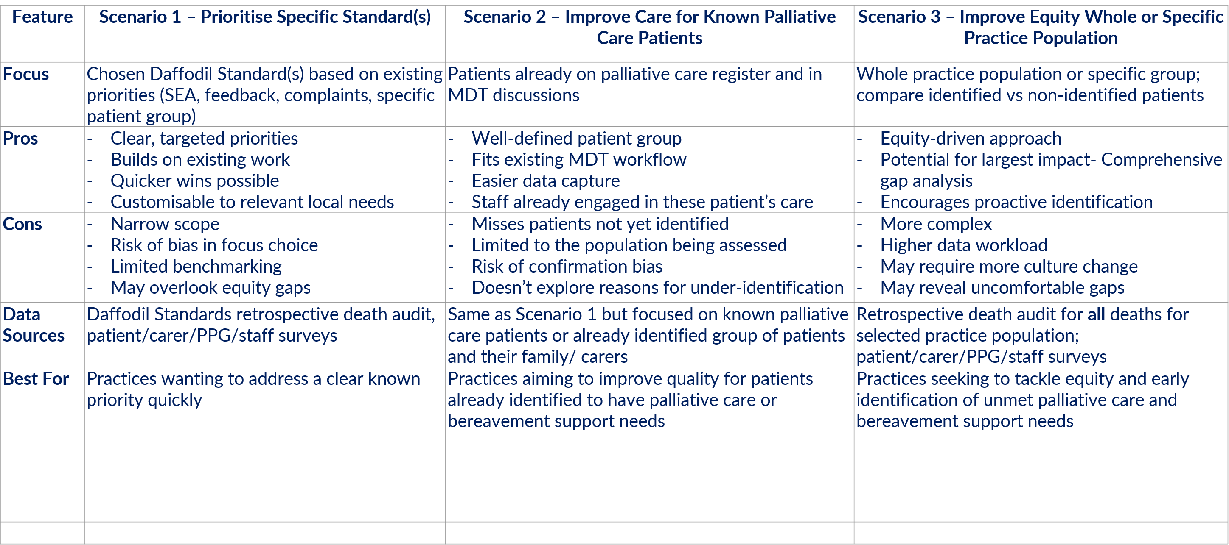
- What is your practice scenario?
Note it here if you’re using this for your evidence

In your diagnostic:
Be specific about what you are initially going to look at:

Population Health
  - Whole practice population
  - A specific group of patients you’re interested in supporting, e.g. care homes, people living with LD & autism,
dementia, frailty, a long-term condition, LGBTI community, people living with physical disability or SMI,
ethnic and cultural disparities, homelessness, people with specific communication & information needs etc
Confirm your focus __________________
  - Other __________________

Which Daffodil Standards are you focusing on?
Standard 1 - Professional and competent staff
            - Standard 2 - Early identification
            - Standard 3 - Carer support
            - Standard 4 - Seamless, planned, coordinated care
            - Standard 5 - Assessment of unique needs of the patient
            - Standard 6 - Quality care during the last days of life
            - Standard 7 - Care after death
            - Standard 8 - General practices as hubs within compassionate communities
            - ALL 8 Standards


Depending on your practice scenario (Step 3), choose your most relevant data collection tool(s) to get started on your
quality improvement journey.

Note – all tools can be adapted to ensure relevance to your practice and quality improvement activity.

1. Practice coded template and dataset (note, this is dependent on how consistently your practice codes data)
  - RCGP & Marie Curie EOLC example Population Summary Audit, After Death Audit & MDT Template
which can be found on the resources page
    - Choose what data from the template you want to audit
    - Note date sent/ complete

2. Patient / Family/ Carer experience
  - Patient / Family/ Carer experience example questionnaire
  - Note format(s) used to collect information e.g. by phone, electronic link, paper copy.
    - How will you ensure equity to complete? e.g. for people with no digital access or other communication
& information needs
  - PPG Pack, note PPG meeting date(s)

3. Practice staff, MDT and wider stakeholder experience
  - Staff & MDT experience of providing EOLC & bereavement example questionnaire
    - Note date sent/ complete
  - Staff experience of the practice’s compassionate leadership and culture example questionnaire
(Daffodil Standard 8 specific)
    - Note date sent/ complete
  - GP neighbourhood pack
    - Note PCN/ GP neighbourhood meeting date(s)
  - Staff Training Needs Analysis example (Daffodil Standard 1 specific)
    - Note date sent/ complete

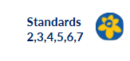
Choose your audit option:
- Practice Population Summary Audit - this can help highlight any specific patient group(s) to focus on
- Practice After Death Audit – this is helpful to assess & diagnose your current practice and compare with evidence
based best-practice
- Practice EOLC MDT Audit – this is helpful to assess people already identified with end of life care needs e.g. on
PC / other register(s) and diagnose unmet need. This will not assess ‘unmet need’ across ‘ALL deaths’ of your whole
or specific practice population (use Retrospective Death Audit for this)
- GP Neighbourhood At-Scale Population Summary Audit with the PCN or Neighbourhood pack found on
the resources page

Be specific about what you are initially going to look at:

Population Health
  - Whole practice population
  - Specific group of patients, e.g. care homes, people living with LD & autism, dementia, frailty, long-term
  - condition, LGBTI community, people living with physical disability or SMI, homelessness, people with specific
  - communication & information needs etc
  - Confirm your focus __________________
  - Other __________________

Which Daffodil Standards are you focusing on?
- Standard 1 - Professional and competent staff
- Standard 2 - Early identification
- Standard 3 - Carer support
- Standard 4 - Seamless, planned, coordinated care
- Standard 5 - Assessment of unique needs of the patient
- Standard 6 - Quality care during the last days of life
- Standard 7 - Care after death
- Standard 8 - General practices as hubs within compassionate communities
- ALL 8 Standards



Hearing the voices of patients, families and carers is vital for learning what works well and what needs improvement in
your practice’s end of life care and bereavement support. Below are detailed steps and guidance for collecting feedback
from both staff and patients or carers.

- Considerations when you’re collecting Staff / MDT experience

- Choose a method – Decide how you’ll collect responses. Online platforms like Microsoft Forms or Google Forms
are efficient, secure and enable anonymisation. Alternatively, printed paper forms can be handed out during team
meetings or left in communal areas.
- Ask meaningful questions – Focus on feedback that supports improvements. Suggested questions:
  - How confident do you feel discussing end of life care and bereavement support with patients or carers?
  - What additional support or training would help you in your role?
- Send the survey – Ensure all staff, including part-time and non-clinical colleagues, receive the survey. Set a clear
deadline for responses (e.g. two weeks).
- Collect and store responses – If using paper forms, place a secure box in the office for anonymous returns.
For online surveys, download a copy and save it in a shared, password-protected folder.
- Review and report – Collate results into a summary sheet. Share key trends or suggestions in your preferred
team meeting and use them to shape future training or improvement changes. Keep a record as evidence for
regulation visits.

- Considerations when you’re collecting Staff / MDT Training Needs Analysis

Tools to use:
- RCGP Daffodil Standards Staff Example Surveys can be found on the resources page
- Format: Online survey platforms (Google Forms, Microsoft Forms) or Suggestion boxes (for ongoing feedback)
- SWOT analysis or Staff / MDT Training Needs Analysis (Daffodil Standard 1 specific)



Can Practice Participation Groups (PPG) get involved? - Yes, they can.
Benefits of Involving PPGs
- Increases transparency and patient-centred care
- Helps uncover blind spots in communication and support
- Supports shared ownership of quality improvement
Actions for practices
- Use the Daffodil Standards PPG pack found on the resources page to act as discussion points for your
PPG and practice to harness feedback and suggestions to help improve care.
- Share a summary of the Standards and ask the PPG to prioritise one to two areas for focused feedback
- Include a standing agenda item on PPG meetings to review progress against the Standards.
Examples – Self-Assessment exercises
Standard one
- 1.3: Ask your PPG to review your end-of-life care goals or priorities
- Encourage PPG members to provide community-level insight into palliative care needs
Standard three
- 3.2: Involve PPG/PPI groups in co-designing holistic carer assessments
- Seek PPG feedback on how carers are supported at your practice
Standard four
- 4.1: Consider involving the PPG in reviewing how MDT meetings improve outcomes for patients and families
Standard eight
- 8.1b: Invite a patient/carer with lived experience (ideally a PPG member) to join a working group or improvement session
- Use PPG discussions to identify gaps in equity, access, or patient voice
- Ensure feedback from PPG is part of your quality improvement cycle.


- Considerations when you’re collecting Staff / MDT feedback
- Select appropriate times – Timing matters. For example:
Aim for six to eight weeks after a patient’s death to gather close family/ friends/ carer insights.
Shortly after a significant care planning conversation.
As part of a regular review if a patient is receiving long-term palliative care.
- Use simple, respectful language – Make sure forms are easy to read and understand. Avoid jargon.
Include questions like:
Did you feel listened to and supported?
Was the information you received helpful and personalised to you?
What could we have done better?
- Offer multiple ways to respond – Consider:
Paper forms at reception or mailed to patients/ carers.
Online feedback forms accessible from your website or if consent, sent by text/ email message.
Verbal feedback gathered by phone or during a follow-up call.
- Collect and file – Ensure consent. Use a confidential method to gather responses. Scan or input data into a secure
system. Mark as anonymous if required.
- Review and act on themes – Collate responses. Summarise common issues or praise. Discuss results in practice
meetings and agree on any necessary changes.

Tools to use:
- RCGP Daffodil Standards Patient and Carer Feedback Example Surveys found on the resources page
- Suggestion boxes (for ongoing feedback)
- Online patient feedback email address or web form
Important Tips:
- Always explain why you're collecting feedback and how it will be used.
- Keep questions optional and feedback anonymous if possible.
- Use a clear feedback summary format so it’s easy to present to others.


Early Identification – Key Evidence Base – Enabling equity of access and care through improved identification of:
People with end-of-life care needs and those requiring bereavement support
You could use supportive and Palliative Indicators Tool (SPICT) or Early ID toolkit to identify people at risk of deteriorating
or dying and those who may benefit from a palliative care approach. Or patients with conditions associated with reduced
capacity may benefit from early personalised care and support planning conversations.

Examples include:
Electronic Proactive Assessment and information Guide for EOLC
Electronic Frailty Index (eFI) can be used in Scotland.
NHS Wales End of Life Care Delivery Plan, Delivery Aim 2: Detecting and Identifying Patients Early

Standard 2 – Early Identification of Patients
60–70% of deaths are predictable (“expected” or “anticipated”) → enabling proactive support.
Patients with conditions associated with reduced capacity may benefit from early personalised care and support planning
conversations.

Standard 3 – Early Identification of Carers, Family/ Friends, NOK, LPA i.e. ‘Who Matters Most’
60–90% of people in their last year of life have an informal carer.
  - They may also have a Next of Kin and/or Lasting Power of Attorney noted.

With the patient’s consent:
  - Record names and contact details
  - Involve who matters most in care decisions
  - Offer/signpost carers to support and bereavement resources

Understand how to identify people - Key data points to collect:
- Demographics: age, gender, ethnicity, cultural/spiritual beliefs, inequality group (e.g., dementia, Black, Asian and
Minority Ethnic, LGBTI, homelessness, deprivation).
- Long term health conditions, disabilities (including learning disabilities) and care home residents
- EOLC Identification: On register, date added.
- Carer Information: next of kin or informal caregiver identified; support offered pre/post-death.
- Process Reliability: Coding consistency, MDT templates, electronic records.
- Care Details: Cause of death, expected vs unexpected, palliative care team involvement, care plans.
- Outcomes: PPD achieved, GP contacts and urgent care use in last three months, bereavement support.
Deep Dive - Equity Check
If your death audit evidences good early identification rates for patients/carers.
Compare across different groups/settings, for example:
  - Own home vs. care home
  - Cancer vs. non-cancer diagnoses
  - People with learning disabilities/autism
  - Different ethnic minority communities
Agree how all members of the practice team can highlight: people who may benefit by being on the Palliative Care
Register and a flagging mechanism on practice computer and what this means for the patient. For e.g. watch
the BMJ: Palliative Care from Diagnosis to Death video to better understand different disease trajectories.
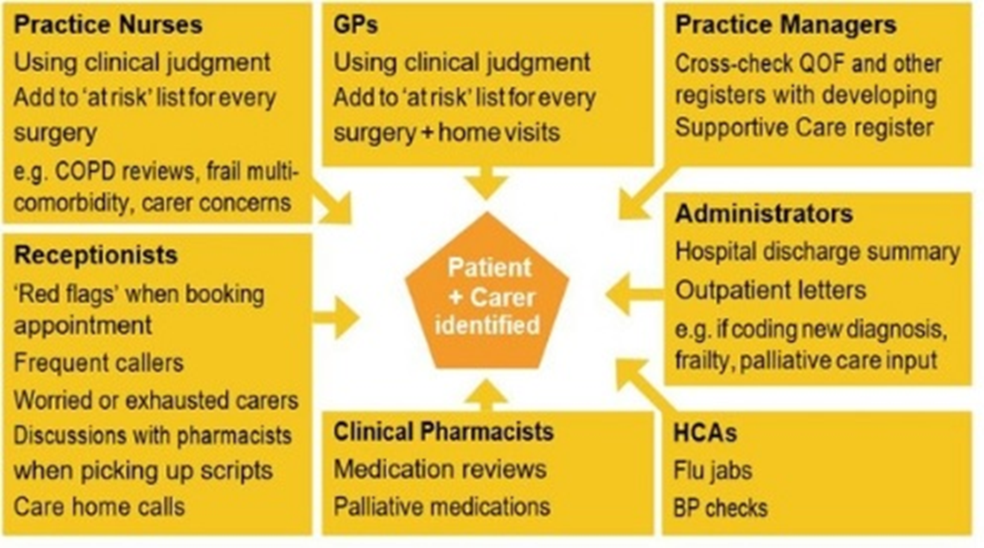

- Input your data into the RCGP & Marie Curie EOLC Example audits & MDT Template
this will allow you to begin to analyse the data and spot trends or themes
- Consider differences between expected and unexpected deaths recorded
- Add EMIS search tool
- Consider which patients have a carer coded on the system. Aim to code more carers
- Discuss how you can create a robust system in place to record and review patients requiring EOLC.
Consider these points:
- Easily accessible register which staff are trained to access and code
- System to flag identified patients to all staff to enable quick, effective decision-making and access
- The practice register size represents an expected proportion of people in the practice with Advanced Serious
Illness and EOLC needs or reasons recorded why this does not align with the local population.
- The number of patients on the Palliative Care Register should be maximised and early identification of
patients is desirable. This should reflect the number of expected deaths that a practice would handle each year.

A simple formula to estimate this is:

Number of expected deaths each year =
Number of deaths (previous year) / Practice population (previous year) x 0.75 (proportion of expected deaths)
Once you’ve collected audit results and feedback, consider the steps below to turn the findings into new,
effective procedures:

- Review the Results Together
- Organise a meeting with your staff/ MDT to go through the audit findings and/or patient / carer/ PPG feedback
and /or staff/MDT feedback.
- Highlight key strengths and identify recurring issues or themes (e.g. coding consistency, missed opportunities,
- gaps in processes/ policies/ templates)

- Prioritise Areas for Change
- Decide which findings are most urgent or impactful to address first.
- Consider using a priority matrix (low/high effort vs. low/high impact)

- Develop Practical Solutions
- Involve relevant staff in creating realistic, efficient solutions.
- Examples: creating a practice MDT template for newly identified and EOLC MDT patients, standardising
bereavement support processes or adding building a consistent processes for carer identification and support

- Draft or Update Procedures
- Use formats that work for your practice staff and population.
- Ensure steps are clear, responsibilities are defined, and instructions are easy to follow.

Standard 1: Professional and competent staff
SWOT analysis or Staff Training Needs Analysis to identify learning needs of staff – in the next 3 months.
Examples of these can be found on the resources page.

Standard 2: Early identification
Increase from 20% to 60% people who die to have been on palliative care (or other register(s)
– over 6 months

Standard 3: Carer Support
Increase from 40% to 60% informal care-giver identification for people on PC register – over 6 months
Increase from 0% to 30% assessment of informal care-giver needs e.g. CSNAT.org – over 12 months
Increase from 0% to 15% sign-posting/ referral to support, as per carers needs - over 12 months

Standard 4: Seamless, planned, coordinated care
Review current and agree future consistent EOLC coding dataset, to used by all staff in the practice, across key Daffodil Standard areas.
Monitor use and repeat review at 6 months
Standard 5: Assess unique needs of the patient
Increase from 20% to 50% of people on PC register to have a care plan – over 12 months

Standard 6: Quality care during the last days of life
Over 12 months, increase from 10% to 50% of people who died on PC register, to document 5 key principles of Priorities for Care of the Dying Person: ‘CRISP’ – Communicate, Recognise, Involve, Support, Plan & Do

Standard 7: Care after death
Increase from 10% to 70% contact bereaved (all deaths) – over 12 months
Increase from 0 to 50% of contacted bereaved, signposting to bereavement support – over 6 months

Standard 8: General Practice as hubs within compassionate communities
Over 12 months, achieve a staff EOLC experience survey + a minimum of 5 patient/ care-giver EOLC experience interviews.
Over 12 months, complete staff & MDT leadership and Culture survey
Confirm the Daffodil Standards you are prioritising:
- Standard 1 - Professional and competent staff
- Standard 2 - Early identification
- Standard 3 - Carer support
- Standard 4 - Seamless, planned, coordinated care
- Standard 5 - Assessment of unique needs of the patient
- Standard 6 - Quality care during the last days of life
- Standard 7 - Care after death
- Standard 8 - General practices as hubs within compassionate communities
- ALL 8 Standards
- Confirm your SMART GOALS
Note it here if you’re using this for your evidence


- Pilot a new procedure
Start small with your PDSA cycle.
Choose a small sample or timeframe to test the new approach (e.g. one month, two patients).
Gather feedback from staff and review whether it worked as planned.

- Schedule follow-ups
Add reminders to repeat audits or collect new feedback regularly (e.g., every 6 months).

- Organise documentation
Keep files securely in a shared drive with clear folders (e.g., Training Logs, MDT Minutes, Audits, Feedback).
Use version control for clarity.

- Finalise and roll out
Make final changes based on pilot feedback.
Share the updated procedure with the team. Consider a short training session, team email, or printed copies in the office.

- Monitor and adjust
Set a review date (e.g., three months) to see how the change is working.
Collect follow-up feedback and adjust if needed.

Example tools you can use:
Action plan templates (to log who’s doing what)
Policy/procedure update template
Improvement log or tracker
Feedback forms


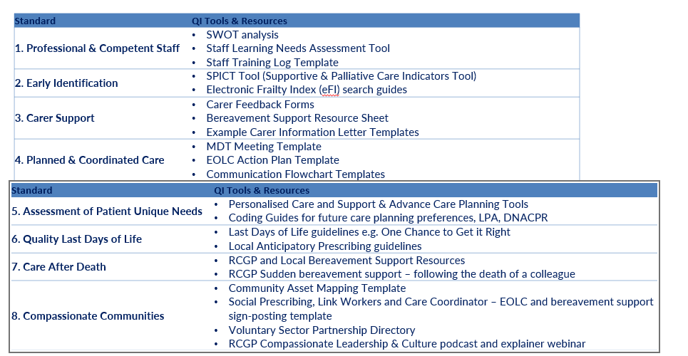
- Use a tracker or action log
Create a simple spreadsheet to log actions taken, responsible persons, and completion dates.

- Keep all documents well organised
Store files securely in a shared team drive. Create folders such as: Training Logs, MDT Minutes, Audits, and Feedback
for clarity.

- Version control
Name documents clearly with the date and version to ensure everyone uses the most up-to-date materials.

- Create short, visual updates
Summarise key improvements in bullet points or a short slide deck. Highlight success stories or positive feedback quotes.

- Share with key stakeholders
Present progress to your staff/ MDT, PPG, primary care networks etc.
Celebrate and share successes, challenges, and learning. Continue to encourage a no-blame, active learning culture.
Include what’s been achieved and what’s next.

- Document good practice
Save real examples (e.g., audit templates, patient feedback summaries, successful MDT agendas) that worked well for
future use.

- Build on your learning
Use feedback and reflections to set new goals or adjust existing ones. Update your tracker or improvement plan
accordingly.
Population Health & Health Inequalities

- Review the information below and identify any population health needs you may wish to prioritise, relevant to
your practice.

Using the Daffodil Standards to focus on:
Supporting people with learning disabilities and their carers

Considerations for practices
Understanding the Unique Needs
- Individuals with learning disabilities may require adjusted communication, extra time, and clear, simple information.
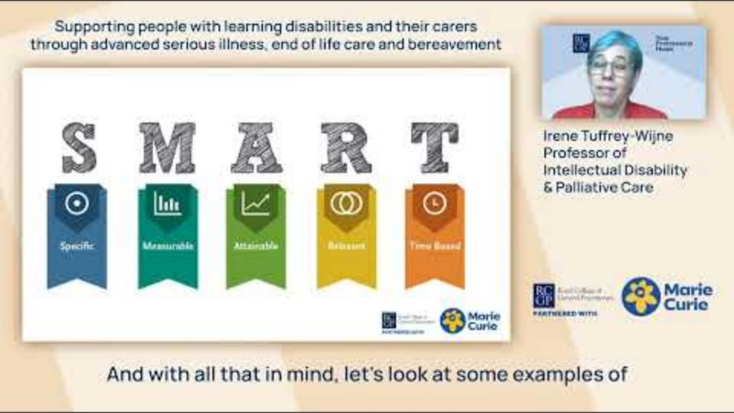
- Consent and mental capacity assessments are essential to ensure the ir voice is heard and respected.
Video created and presented by: Irene Tuffrey-Wijne
Professor of Intellectual Disability​ & Palliative Care

Involving Trusted Carers and ‘Who Matters Most’ to the patient
  - Carers (family or support workers) are vital partners in care—practices should identify and engage them from the outset.
  - Their insight is crucial throughout advance care planning and decision-making.

Early Identification & Planning
  - Practices should proactively flag patients with learning
disabilities who may need end of life care.
  - Use structured tools like SPICT with adjustments to recognise complex needs early.

Adapting Communication
  - Use accessible tools to enable future care planning e.g. EOLC toolkit viewable here: https://www.victoriaandstuart.com/
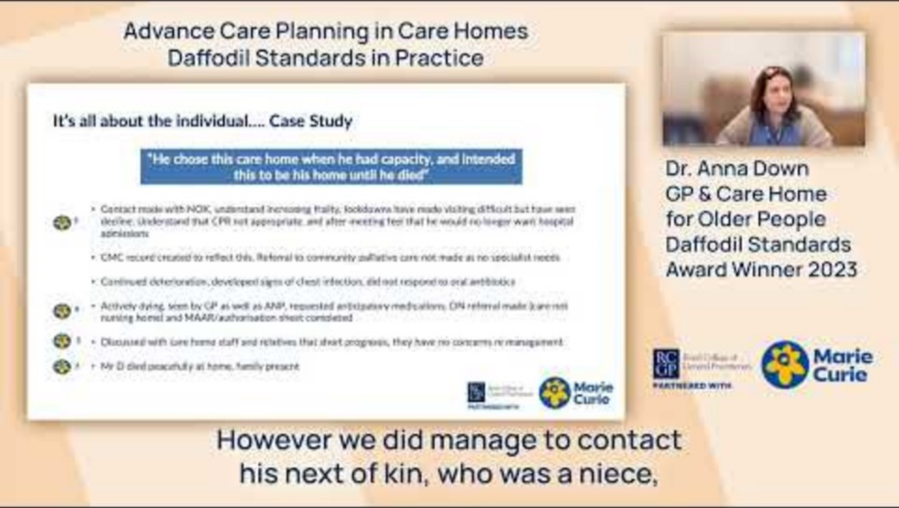
Actions for practices
Create a Register of Care Home Residents
- Maintain an up-to-date list of all patients living in local
care homes.
- Include key data: care home name, GP assigned, DNACPR status, advance care plan status.

Schedule Regular Reviews
- Coordinate routine clinical reviews between GPs
- and care home staff.
- Schedule MDT meetings involving practice nurses, pharmacists, or palliative care teams if appropriate.

Improve Communication
- Provide care homes with a named point of contact within the practice.
- Identify ‘who matters most’ to the patient and record their name, contact details, LPA status.
- Use a shared communications log or folder (if possible).
The RCGP Daffodil Standards also support practices that care for older people living in care homes.
This includes people with complex needs, frailty, or approaching the end of life.
The RCGP Daffodil Standards also support practices that care for
older people living in care homes. This includes people with
complex needs, frailty, or approaching the end of life.
Video created and presented by Dr Anna Down​
Care Home for Older People Daffodil Standards Award Winner 2023
The RCGP Daffodil Standards also support practices that care for
older people living in care homes. This includes people with
complex needs, frailty, or approaching the end of life.
Track Training & Support
  - Keep a record of care home-related training attended by staff.
  - Offer guidance materials to care home staff (e.g. symptom monitoring sheets).

Support End-of-Life Planning
  - Help ensure care plans and preferences are recorded and accessible.
  - Update the practice’s EOLC register as patients’ situations change.

Tools to use
- Palliative Care, Advance Disease and Frailty registers
- MDT care home meeting template to include key Daffodil Standards dataset
- Advance care planning documentation tools
- https://www.rcgp.org.uk/news/joint-statement-on-advance-care-planning

These resources can help your practice deliver more joined-up, compassionate care for care home residents
and improve continuity across settings.
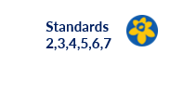
We're keen to find out your thoughts on the new guide and where we can improve. Your feedback is important to us,
and you can choose for your responses to be anonymous. Please fill out this 5 min survey.

Tell us, your thoughts on the Daffodil Standards "How to Get Started Guide"
If you’re get to this slide and you’ve discussed ideas with your team / peers/ supervisor/ wider neighbourhood
and you’re still unsure where to start – please get in touch with daffodilstandards@rcgp.org.uk
to request a mentoring session with our Clinical Champion: Dr Catherine Millington-Sanders.
Got a query that’s stopping you progressing? Or Need some ideas/ support?
- you can use the Daffodil Standards: Example EoLC audit dataset SMART goals document on the learning
resource page.

- Several example case studies can be found on the Daffodil Standards webpage. These may you identify
key themes you want to prioritise from your data

- You can also watch the training videos: Using the Daffodil Standards to focus on: Supporting people with
learning disabilities and their carers (page 30).

- Or Using the Daffodil Standards to focus on: Supporting older people in care homes (page 31)
Which baseline data collection tool?
Example Case Studies

Acknowledgements

The development of the How to Get Started guide for the RCGP and Marie Curie Daffodil Standards has been
a collaborative effort, and we would like to express our sincere thanks to all those who have contributed their
time, expertise, and insight.

Project Team
- Zoe Calder, RCGP, Senior PMO Manager, Programme Management Office
- Lizzie Richmond, RCGP, Project Manager, Programme Management Office

Clinical Advisors
- Dr Catherine Millington-Sanders, RCGP & Marie Curie National Clinical End of Life Care Champion
- Professor Irene Tuffrey-Wijne, Professor of Intellectual Disability​ & Palliative Care
- Dr Anna Down​, Care Home for Older People Daffodil Standards Award Winner 2023

Evaluation input and GP practice contributors
- Professor Margaret Ikpo, RCGP Vice Chair of Professional Development
- Dr Nazmul Hussain, GP EOL Lead
- Christina Cleworth, Practice Manager
- Dr Emma Husbands, Consultant Palliative Medicine
- Lorna Tenconi, Cancer Social Prescriber
- Dr Tom France, GP Registrar (ST3) and RCGP National GP Registrar Vice Chair
- Dr Tabitha Winnifrith, GP
- Julie Hall, Care Coordinator
- Louise Lee, ACP
- Andy Holness, Patient & People's Voice Partner,

Partner Organisations
We acknowledge the support and expertise of our funding partner Marie Curie.

- 7 anonymous Julie Hall
- 8 anonymous louise lee

Partner Organisations
We acknowledge the support and expertise of our funding partner Marie Curie.

- ACP - Advance Care Planning
- CPD - Continuing Professional Development
- DNACPR - Do Not Attempt Cardiopulmonary Resuscitation
- DS - Daffodil Standards
- EFI - Electronic Frailty Index
- EOLC - End of Life Care
- ICB - Integrated Care Board
- LPA - Lasting power of Attorney
- MDT - Multi Disciplinary Team
- PEOLC - Palliative and end of Life Care
- PCN – Primary Care Network
- PPD - Preferred Place of Death
- PPG - Patient Participation Group
- PPI - Patient and Public Involvement
- SEA - Significant Event Analysis
- SMART goals - Specific, Measurable, Achievable, Relevant, and Time-bound
- SPICT - Supportive and Palliative Care Indicators Tool
Acronyms used in this "how to get started" guide

